ACTIVITY 15

NAME: Rose Mystica. J COURSE: MOBILE COMPUTING
REG NO : 192421410 COURSE CODE: ITA0302

15) Design an interactive presentation in Figma explaining the issues in mobile IP.
Aim:
To Design an interactive presentation in Figma explaining the issues in mobile IP
Procedure:
1. Define Presentation Structure
2. Create a Figma Project
3. Design Visual Elements
4. Make it Interactive
5. Add Annotations and Explanations
6. Incorporate Multimedia
7. Storyboard Animation
8. Test the Prototype
9. Collaborate and Gather Feedback
10. Finalize and Share

Step By Step Procedure :
Interface Of Experiment:


Interface Of Experiment:

Next Page:
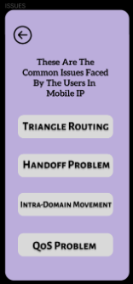
Final Step:
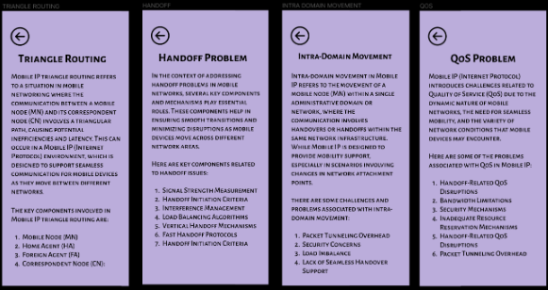
Prototype:
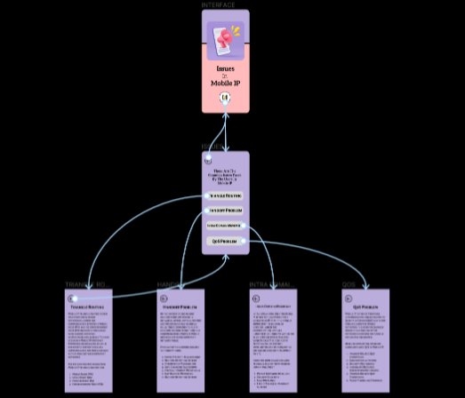
Result:
Hence the interactive presentation in Figma explaining the issues in mobile IP is created
and executed successfully.

